# Documentation

**4.1 Banner Grabbing**

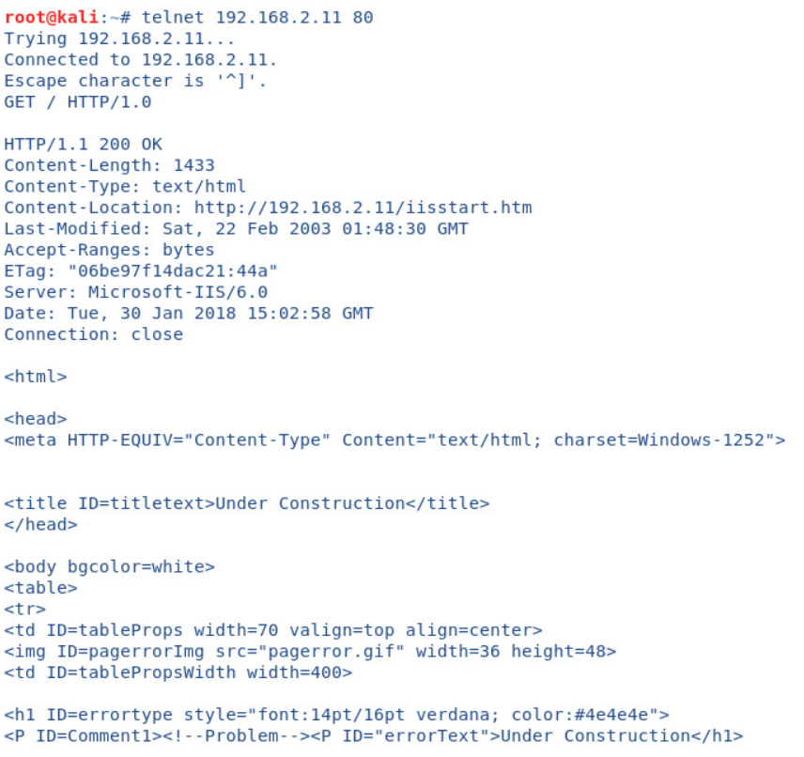

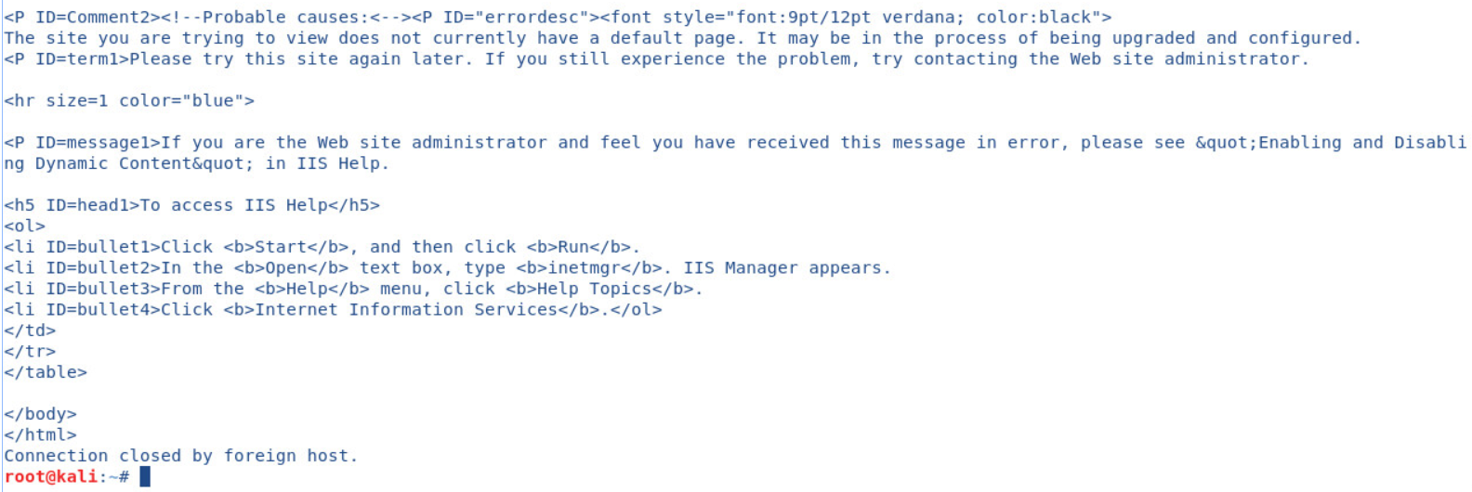

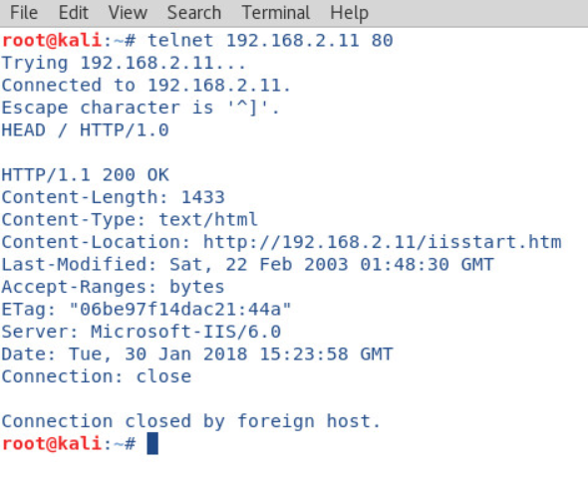

**4.2 Null Sessions**

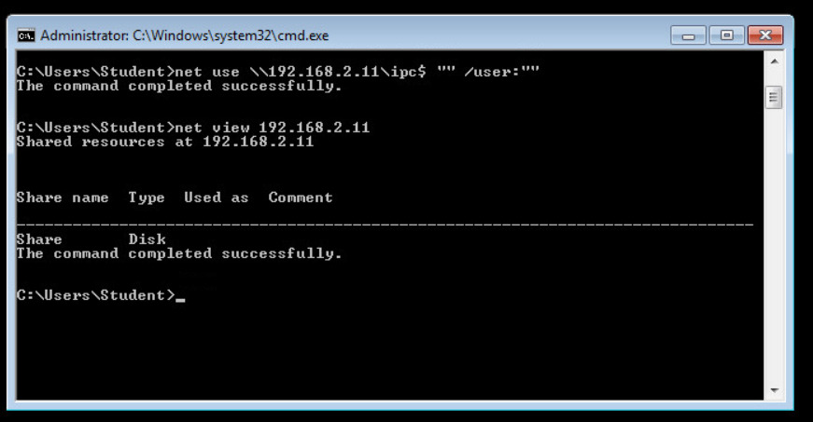

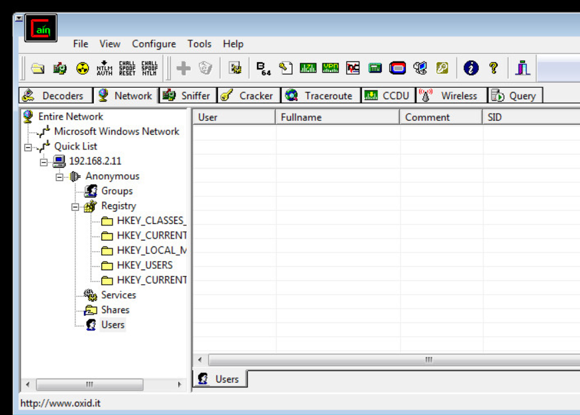**When I clicked on Users. It gave me the following prompt: “Users enumeration error: Access is denied”**

**4.3 NetBIOS Enumeration**

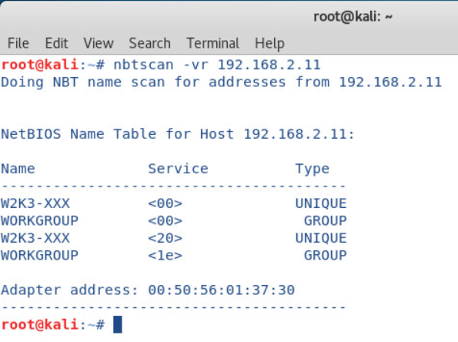

**4.4 SMTP Enumeration**

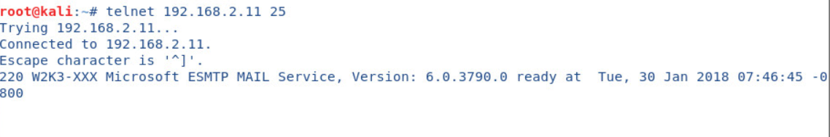

# Vulnerabilities

No vulnerabilities discovered in this lab.